|  |  |  |  |  |  |  |
| --- | --- | --- | --- | --- | --- | --- |
| **Mehran University of Engineering & Technology,**  **Jamshoro** | |  | **Subject** | | | |
| **Web Technology** | | | |
| **Department of:**  **Bachelor of Science Computer Science** | | **Year** | **2nd** | **Semester** | **3rd** |
| **Roll No:** | **20BSCS043** | **Batch** | **20BSCS** | **Duration** | **3 Hours** |

**PRACTICAL # 1**

**TO PRACTICE THE BASIC TAGS OF HTML**

**Task # 1:** What is Html? Discuss what is difference between html tags and html element?

HTML:

HTML (HyperText Markup Language) is **the most basic building block of the Web**. It defines the meaning and structure of web content.

|  |  |
| --- | --- |
| **HTML TAGS** | **HTML ELEMENTS** |
| HTML tags are used to hold the html  elements. | HTML elements holds the contents. |
| HTML tags starts with <> and ends with  </>. | HTML elements are enclosed within HTML Tags. |
| HTML tags are almost like keywords where every Tag has its own special meaning. | HTML elements specifies the general content. |

**Task # 2:** Make a webpage which will show your bio data (e.g: Name, fathers name, class, roll no, address, contact no, email address etc.). Use headings etc.

**CODE:**

**Output:**

**Task #3:** Apply 3 web links on your web page. Also place at least 3 images.

**Code:**

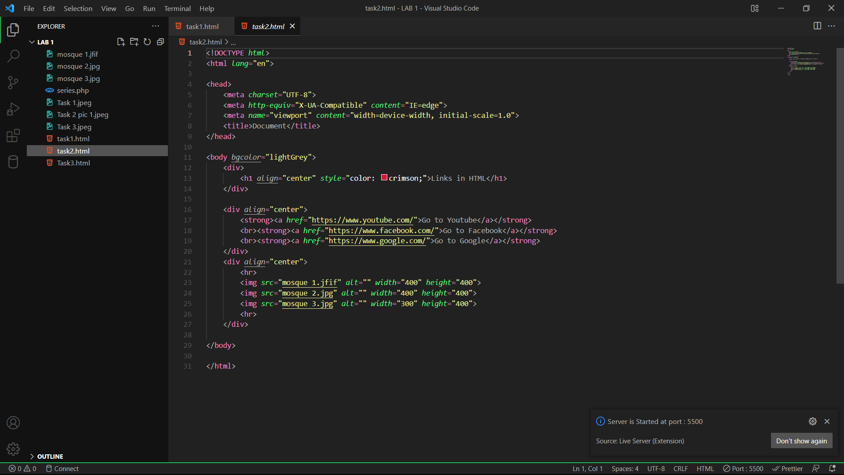

**Output:**

**Task #4:**

Make a web page which will show page header, body & footer. Size of header should be same as footer. Apply some font attributes in body section.

**CODE:**

**OUTPUT:**

